**Exercise: Applying Task-Centered System Design**

Your job is to perform a task-centered walkthrough of the prototype described below. Sample tasks are provided at the end of this page.

**The Prototype**

The system below is used by the Cheap Shop Department Store, a catalog-based store similar to Consumer's Distributors. Shoppers in the store decide on the item they want by browsing a paper catalog, and can then purchase items by entering the relevant information into the screens below.

**Screen 1** 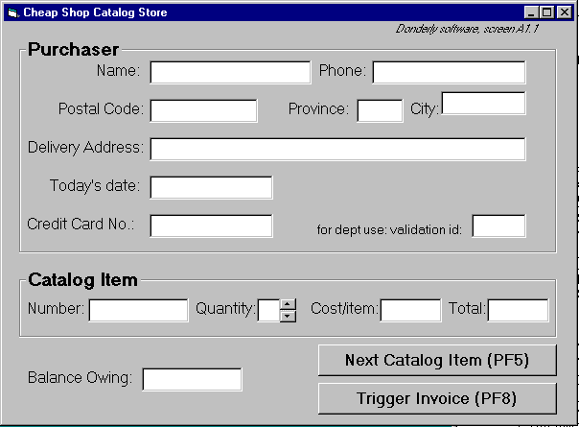

**Screen 2** 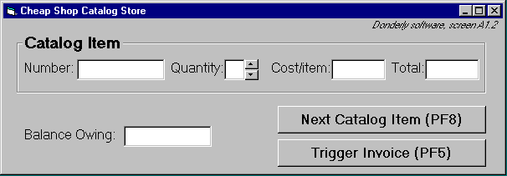

**Specifications**

* To create an order
  + On screen 1, shoppers enter their personal information and their first order
  + text is entered via keyboard
  + the tab or mouse is used to go between fields.
* Further orders
  + shoppers go to the 2nd screen by pressing the Next Catalog Item button
* Order completion
  + shoppers select ‘Trigger Invoice’.
  + the system automatically tells shipping and billing about the order
  + the system returns to a blank screen #1
* To cancel order
  + Shoppers do not enter input for 30 seconds (as if they walk away)
  + The system will then clear all screens and return to the main screen
* Input checking
  + all input fields checked when either button is pressed.
  + erroneous fields will blink for 3 seconds, and will then be cleared.
  + the shopper can then re-enter the correct values in those fields.

**Example Task Descriptions for "Cheap Shop"**

Fred Johnson, who is caring for his demanding toddler son, wants a good quality umbrella stroller (red is preferred, but blue is acceptable). He browses the catalog and chooses the JPG stroller (cost $98. item code 323 066 697). He pays for it in cash, and uses it immediately. Fred is a first-time customer to this store, has little computer experience, and says he types very slowly with one finger. He lives nearby on Dear Bottom Avenue NW.

Mary Vornushia is price-comparing the costs of a child’s bedroom set, consisting of a wooden desk, a chair, a single bed, a mattress, a bedspread, and a pillow all made by Furnons Inc. She takes the description and total cost away with her to check against other stores. Three hours later, she returns and decides to buy everything but the chair. She pays by credit card, She asks for the items to be delivered to her daughter’s home at 31247 Lucinda Drive, in the basement suite at the back of the house. Mary is elderly and arthritic.

John Forham, the sole salesperson in the store, is given a list of 10 items by a customer who does not want to use the computer. The items are: 4 pine chairs, 1 pine table, 6 blue place mats, 6 “lor” forks, 6 “lor” table spoons, 6 “lor” teaspoons, 6 “lor” knives, 1 “tot” tricycle, 1 red ball, 1 “silva” croquet set After seeing the total, the customer tells John he will take all but the silverware The customer then decides to add 1 blue ball to the list. The customer starts paying by credit card, but then decides to pay cash. The customer tells John he wants the items delivered to his home the day after tomorrow. While this is occurring, 6 other customers are waiting for John.

John has been on staff for 1 week, and is only partway through his training program

**The Walkthrough Process**

* Select one of the tasks scenarios
* For each user's step/action in the task:
  + can you build a believable story that motivates the user's actions?
  + can you rely on user's expected knowledge and training about system?
* if you can't:
  + tell a believable story about an action,
  + assume knowledge they would not have,
  + then you've located a problem in the interface!
* once a problem is identified, assume it has been repaired
* go to the next step in the task

**Sample Walkthrough Template**

Task number ____

|  |  |  |  |
| --- | --- | --- | --- |
| **Description of Step** | **Does the user have the knowledge / training to do this step?** | **Is it believable that they would do it? That is, are they motivated?** | **Comments (including possible solutions)** |
|  |  |  |  |
|  |  |  |  |
|  |  |  |  |
|  |  |  |  |
|  |  |  |  |
|  |  |  |  |
|  |  |  |  |
|  |  |  |  |
|  |  |  |  |
|  |  |  |  |
|  |  |  |  |
|  |  |  |  |
|  |  |  |  |
|  |  |  |  |
|  |  |  |  |
|  |  |  |  |
|  |  |  |  |
|  |  |  |  |
|  |  |  |  |
|  |  |  |  |
|  |  |  |  |
|  |  |  |  |
|  |  |  |  |
|  |  |  |  |
|  |  |  |  |
|  |  |  |  |
|  |  |  |  |
|  |  |  |  |